Working with Visual Reports
Visual reports are graphical type reports that are available in Project 2010. These reports are defined using a template in Project 2010 and use either a Visio PivotDiagram or Excel PivotTable technology to generate the final report. Once a report is generated, changes and fine-tuning of the report can be performed through Visio or Excel.
Since Visual Reports use Pivot table technology, knowledge of Pivot tables is helpful for the project manager to gain the greatest benefit from these reports.
In this chapter we will discuss:
Overview of Visual Reports
The Anatomy of Pivot Tables
Viewing a Visual Report
Creating a Visual Report template
Overview of Visual Reports
Visual Reports are reports based on dimensions and measures that produce graphs using Pivot Tables. Pivot Tables will be discussed in the next lesson. When a Visual Report is run, an On-line Analytical Processing (OLAP) cube of data is built based on the metrics stated in the specifications for the Visual Report. After the cube is built, Project 2010 connects to either Visio or Excel to display the report. If an Excel-based report is selected, the report will be based on Pivot Tables. If a Visio-based report is selected, a Visio Pivot Diagram will be produced.
Once a report is generated, it can be manipulated as a Pivot Table and tailored to fit your needs. Types of manipulations include expanding and contracting outline levels, changing field values, selecting options, adding totals and changing the appearance of graphs. After the Visual Reports are generated, they can be saved or published to a reporting website.
Project 2010 provides multiple Visual Report definition templates found in the Visual Reports - Create Report dialog box. Options are available to filter the Excel templates from the Visio templates. All templates are contained in the All tab within the dialog box.
Sub tabs are provided for various report categories, and contain the following report options:
Task Summary Tab
Report | Content | Excel or Visio
Critical Tasks status report (Metric) | Work and Work remaining for critical and non-critical tasks. | Visio
Critical Tasks status report (US) | Work and Work remaining for critical and non-critical tasks. | Visio

Resource Summary Tab
Report | Content | Excel or Visio
Resource remaining work report | Work, Remaining Work, total Work for work resources. | Excel

Assignment Summary Tab
Report | Content | Excel or Visio
Resource status report (Metric) | Work and Cost values per resource. | Visio
Resource status report (US) | Work and Cost values per resource. | Visio
Task status report (Metric) | Work and percent of work completed by WBS level. | Visio
Task status report (US) | Work and percent of work completed by WBS level. | Visio

Task Usage Tab
Report | Content | Excel or Visio
Cash flow report | Timephased task cost data. | Excel

Resource Usage Tab
Report | Content | Excel or Visio
Cash flow report (Metric) | Baseline Cost vs Actual Cost over time by resource type. | Visio
Cash flow report (US) | Baseline Cost vs Actual Cost over time by resource type. | Visio
Resource Availability report (Metric) | Total capacity, Work and remaining availability per. resource | Visio
Resource Availability report (US) | Total capacity, Work and remaining availability per resource. | Visio
Resource cost summary report | Resource costs per resource type. | Excel
Resource work availability report | Work and remaining availability over time. | Excel
Resource work summary report | Work, Actual Work and Remaining Availability per resource. | Excel

Assignment Usage Tab
Report | Content | Excel or Visio
Baseline Cost Report | Compares Baseline Cost, Actual Cost and Cost. | Excel
Baseline Report (Metric) | Baseline, Actual Work and Cost over time. | Visio
Baseline Report (US) | Baseline, Actual Work and Cost over time. | Visio
Baseline Work Report | Baseline Work, Baseline Cost, and Actual Work. | Excel
Budget Cost Report | Budget Cost, Baseline Cost, Cost and Actual Cost. | Excel
Budget Work Report | Budget Work, Baseline Work, Work, Actual Work. | Excel
Earned Value Over Time Report | Timephased – Actual Cost of Work performed, baseline values and Earned Value. | Excel

Anatomy of a Pivot Table
To understand Visual Reports, some understanding of Pivot Tables is helpful. Pivot Tables are flexible tables based on measures and dimensions. The information below is an overview of a Pivot Table based report. Additional information regarding Pivot Tables can be found in any Excel reference book, through software Help, or online.
In the table below, sales data from The Chocolate Company shows that sales of different products have occurred in multiple locations. The Chocolate Company also keeps track of the customer type and products sold. We might want to know total sales by customer type, product or location. Pivot Tables have the flexibility to process any of these report requests quickly.
The data below is the source data that will be used to generate the Pivot Table:
Pivot Table sample data
Customer | Customer type | Location | Product | Quantity in bars | Price
Customer A | Retail | Chicago | Dark | 48 | 120
Customer B | School | Rome | Milk | 24 | 60
Customer C | Vending | Sydney | White | 12 | 30
Customer D | Retail | Chicago | Dark almonds | 36 | 45
Customer E | School | Rome | Milk almonds | 48 | 120
Customer F | Vending | Sydney | White peanuts | 24 | 60
Customer G | Retail | Chicago | Dark | 12 | 30
Customer H | School | Rome | Milk | 36 | 45
Customer I | Vending | Sydney | White | 48 | 120
Customer J | Retail | Chicago | Dark almonds | 24 | 60
Customer K | School | Rome | Milk almonds | 12 | 30
Customer L | Vending | Sydney | White peanuts | 36 | 45
Customer M | Retail | Chicago | Dark | 48 | 120

In the view below, a Pivot Table has been created using the above data. The data below is consolidated to show sales by Customer type:
Customer Type and Sum of Price data from Pivot table
Customer Type | Sum of Price
Retail | 480
School | 180
Vending | 90
Wholesale | 135
Grand Total | 885

In the next example, the table was changed to show sales by Location:
Location and Sum of Price data from Pivot table.
Location | Sum of Price
Chicago | 375
Rome | 255
Sydney | 255
Grand Total | 885

In the next example, sales by Product:
Product and Sum of Price data from Pivot table.
Product | Sum of Price
Dark | 270
Dark almonds | 105
Milk | 105
Milk almonds | 150
White | 150
White peanuts | 105
Grand Total | 885

Pivot Tables are easily changed to create the type of report necessary for your reporting needs, based on the values contained in the Pivot Table data. Visual Reports will be used to create the Pivot Diagram or Pivot Table but the project manager will need to customize the generated report.
Viewing Visual Reports
Project 2010 comes with built in Visual Report templates to report on cost, work and resource data. Having a specific goal in mind for the type of report you want will help generate more meaningful report data.
To open the Visual Reports – Create Report dialog box:
Project → Visual Reports
To create a report:
Select any report.
Change timeframe for assignment (usage) data.
Click View.
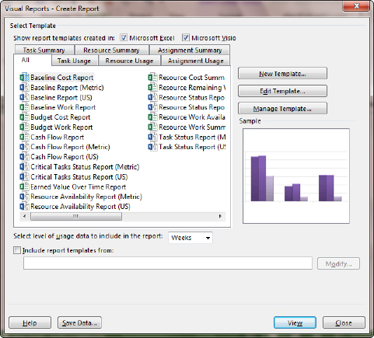
Visual Reports Create dialog box.
The report will generate by creating an OLAP cube and will open either Visio or Excel. In the generated Pivot Table select the data to be viewed on the report. Notice that the data viewed on the table can also be viewed in chart format.
Options are available for saving the generated OLAP cube or creating an Access database from the data by clicking the Save Data… button.
Creating Visual Report Templates
Creating customized Visual report templates will allow inclusion of customized fields in Visual Reports. Standard templates can also be edited to include or exclude selected data. Visual Report templates are created as .xlt Excel Templates or .vst Visio Template types.
To edit a standard template:
Project → Visual Reports.
Select any report.
Click Edit.
See instructions for field choices below.
To create a new Visual report template:
Project → Visual Reports.
Click New Template.
Visual Reports – New Template dialog box opens:
Select Application: Visio or Excel.
Select Data Type (destination for completed template).
For Timephased data select:
Task Usage
Resource Usage
Assignment Usage
For total project information select:
Task Summary
Resource Summary
Assignment Summary
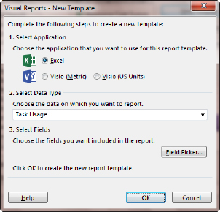
Visual Report New Template dialog box.
Click on the Field Picker button.
Add and remove fields from the report:
Select fields to add to the report on the left side and click Add.
Select fields to remove from the report on the right side and click Remove.
Click OK when field selection is completed.
Click OK to generate a report based on the selected criteria.
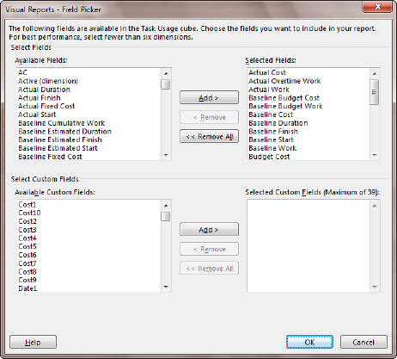
Visual Reports Field Picker dialog box.
An OLAP cube will be generated and the will open in either Excel or Visio.
To save the template:
In either Excel or Visio click the Office button → Save As .
Give the template a name and leaving the template file extension of .xlt for Excel or .vsd for Visio.
Click OK to create and save the template.
The following message will appear when an Excel template is created:
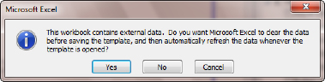
Visual Report warning message.
Click Yes to refresh or create new data when the template is run.
The new template will be added to the list of already available Visual Report templates. In the example below, a new template called New Visual Report Template was created.
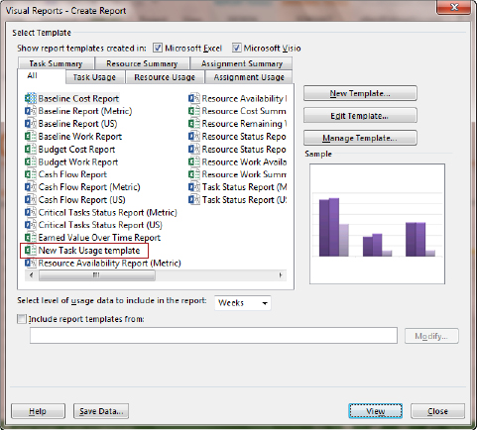
New Task Usage Template created.
To rename or delete an existing template:
Click the template to be renamed or deleted.
Click Manage Template.
Right-click the file.
Select Rename or Delete.
Visual Report templates are not stored in the Organizer. They are stored with the templates for Visio or Excel. They can only be executed from the Visual Reports dialog box in Microsoft Project.
Dashboard Reports
What are Dashboard Reports?
Dashboard reports are reports that display project data is tabular and graphic form. Each report displays different data and can be customized to tailor the reports for each users needs.
Below is an example of the Overallocated Resources Dashboard Report. Note that there are 2 charts each representing different resource data. The chart on the left represents Actual work v Remaining Work. The chart on the right is displaying resources that are Overallocated at the day level. Each of these reports may be altered to adjust the chart type, chart elements and details of the display data.
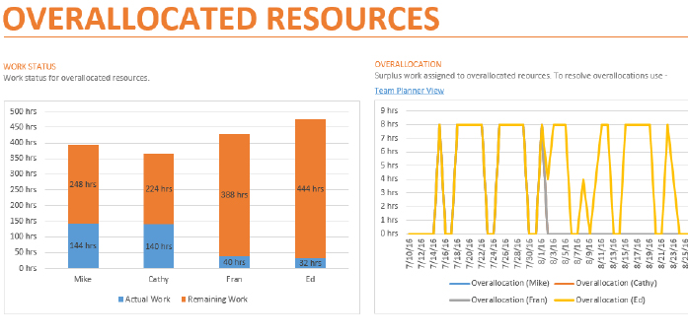
Dashboard report – Overallocated Resources.
Data Included in the Dashboard Reports
Dashboard Reports contain data relating to project progress, variance calculations, and critical path. Below are listed some of the data which are included in the reports. If you are not using the data needed to populate the reports, the reports will not display properly.
Some of the data needed for the reports includes the following project data values:
Task Duration, Cost and Work.
Resource Cost and Work.
Baseline comparison.
Status date.
Status field: Late, On Time, Future
See below for a list of the Dashboard Reports and the data which is represented on each report. Use this as a guide to decide which reports would be useful for you.
Reports that come with Microsoft Project 2013
Reports included in the Dashboard group of reports
Report Name | Data Shown on Report
Burndown | 1) Remaining Cumulative Work v. Baseline Remaining Cumulative Work for active tasks; 2)  Number of tasks completed and number left to be completed
Cost overview | 1) Cumulative Percent Complete, Cumulative Cost; 2) Remaining Cost, Actual Cost and Baseline Cost; 3) Cost outline summary level 1 tasks
Project overview | 1) Percentage complete of Outline level 1 tasks; 2) List of milestones and target dates; 3) Late tasks – tasks that are past due
Upcoming Tasks | 1) Work Percent complete is less than 100%, tasks starting within 5 days of system date; 2) Tasks starting soon list
Work Overview | 1) Remaining cumulative Work, Remaining Cumulative Actual Work, Baseline Remaining Cumulative Work; 2) Baseline work, actual work, remaining work at outline level 1; 3) Actual work v remaining work by resource and 4) Remaining availability by resource

Reports included in the Resources group of reports
Report Name | Data Shown on Report
Overallocated Resources | 1) Actual work v Remaining work; 2) Hours assigned to overallocated resources
Resource Overview | 1) Remaining work, Actual work, Baseline work; 2) Percent work completed by resource; 3) Remaining work assigned by resource

Reports included in the Cost group of reports
Report Name | Data Shown on Report
Cash flow | 1) Cost v Cumulative Cost, Cost Variance – Project Summary level; 2) Outline level 1 summaries Remaining cost, Actual Cost, Cost and Earned Value
Cost Overruns | 1) Task Cost Variance; 2) Resource Cost Variance
Earned Value Report | 1) Actual cost of work performed, Baseline cost of work performed, Baseline cost of work scheduled; 2) Cost Variance, Schedule Variance; 3) Cost Performance Index (CPI), Schedule Performance Index (SPI)
Resource Cost Overview | 1) Resource Remaining Cost, Actual Cost, Baseline Cost; 2) Cost distribution over resource types; 3) Cost details at the resource level
Task Cost Overview | 1) Cost status – Actual Cost, Remaining Cost, Baseline Cost; 2) Costs spread out amoungst tasks based on their status (On Schedule, Late, Future); 3) Cost Details – outlne level 1

Reports included in the In Progress group of reports
Report Name | Data Shown on Report
Critical Tasks | 1) Chart – On Schedule, Late, Future 2) Table task level critical tasks
Late Tasks | 1) Chart – On Schedule, Late, Future; 2) Table task level – tasks that are late compared to status date.
Milestone Report | Late Milestones, Milestone up next and Completed Milestones
Slipping Tasks | 1) Remaining Cumulative Work, Remaining Cumulative Actual Work; 2) Task list for tasks where finish date are past the baseline finish date.

To Display a Dashboard Report
Click on the Reports tab
Click on a Report Category: Dashboards, Resources, Costs, In Progress
Click on a Report to display
To change parameter values displayed on a Dashboard Report:
Click on the Reports tab
Click on a Report Category: Dashboards, Resources, Costs, In Progress
Click on a Report to display
Click inside of a graph. Options will appear on the right side of the view.
Change options as necessary. Close by options by clicking on the X in the upper left corner of the options box.
Other changes may be made by clicking on formatting changes on the Design ribbon which will appear when a Report is selected.
Changes to Dashboard Reports will be remembered within the file.
Clicking on the Page Breaks button will display the page breaks as for printing the report. The separate report graphics and tables may be dragged to different pages for printing purposes.
More Reports Dialog Box
The last option in all of the pull down choices of the Dashbroard Reports is More Reports. Clicking on this option will display the More Reports dialog box.
To change options while viewing this dialog box, click the reports types on the left side of the dialog box. The Custom choice will store your custom created reports. The Recent choice will show the recently viewed reports.
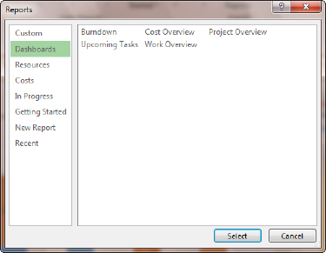
More reports dialog box
Creating a New Dashboard Report
The Dashboard Reports provided with MS Project 2013 are suggestions of the kinds of reports that you might need when reporting on your project. The Dashboard Reports customization feature allow you to create new reports and customize existing reports. Using this feature will provide more flexiability to create the solution to your reporting needs.
When creating a new report you must define the kind of report you would like to create. It is best to design what the charts should look like and what data should be included before starting this process. Changes can easily be made to reports created so you should not be too concerned about getting it right the first time.
In this example we will build a new Dashboard report to compare Baseline Work to Actual Work for resources in a chart. We will also see the progress of our top level (the highest level of the WBS Outline level 1) summary tasks. In addition we will add a title for the report and a picture which will represent a company logo. When the new Dashboard Report is completed it will be copied into the Organizer to be used in other projects.
To start a new Dashboard report:
Click on Report, New Report.
Options are available to select a template to get you started. You may select a blank template, a chart, a table or a comparision type report. Any of these elements may be added to the report later to enable you to have more than one type of element type section included in a report.
Select a template type
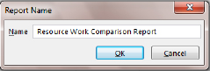
New Dashboard report name box
The choosen template will open with the report name centered across the top of the report. In the example below a chart style template had been selected. The default is displaying work comparison at the summary task or top level task summary.
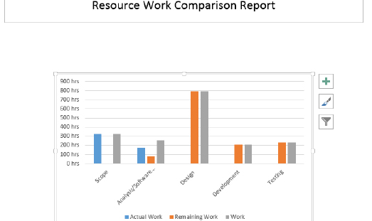
Display of chart template for Dashboard Reports
The data being displayed is Task data, work. To change the data displayed on the chart from Task data to Resource Data, work:
Click on the chart
Iin the Chart Tools ribbon bar click on Design, click on Chart Data
Resources at the top of the Field List
The Field list will allow for changes to the report which include field selection, filters, groups, outline level and sorting. In the example below the data has changed to Resource work comparison.
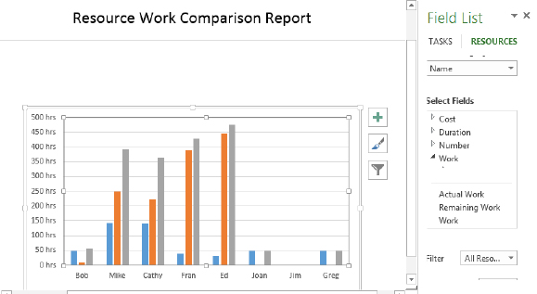
The Field List displayed to customize a Dashboard Report
To change the chart type:
Click inside of the chart
In the Report Design ribbon section click on Chart
Select and alternate chart type
The Chart, Design ribbon also contains tools for adding other chart elements, quick layout, changing chart colors and changing style designs. On the Report, Design ribbon you will find tools for Themes, color palates, inserting images and margin settings. In the example below the chart type has been changed from column to bar and a chart style was applied.
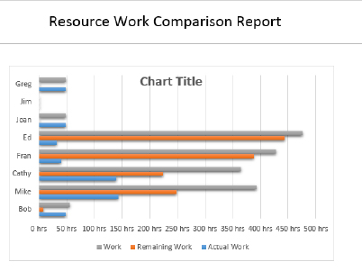
Dashboard Report displaying bar chart format
To add a table to the Dashboard Report scroll up and click underneath the existing chart.
Click on Report Tools, Design, Table
The new table will be added with 4 columns: Name, Start, Finish, %Complete. It will also show as one line which is the information contained in the Project Summary task.
To expand the information to Outline level 1 data:
Click in the table
The Field List will appear at the right
Scroll down to Outline level and select Outline level 1.
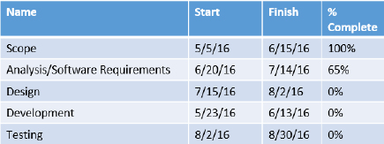
Default table format expaneded to Outline level 1
To add a column to the table:
If the Table data pane on the right side of the view is not available:
Click inside the table
Click on Table Tools, Design, Table data
Scroll through the fields that can be added to the table on the right. Open sections of fields to find the field you need. To add the Work field to the table, open the Work section and select Work under the Work section.
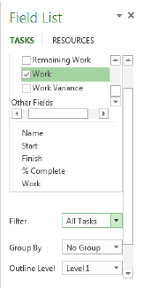
Field list with work selected
To reorder the fields in the table:
Scroll down in the Field List to just above the Filter option. Select Work (the last field added) and drag it up under the Name field.
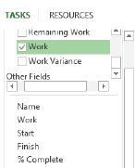
Field Work reordered to display next to the Name field.
To add a logo to the report:
To change the formatting of an words, add shapes, rotate object, resize or apply shape styles: Select the element to change, Click on the Drawing Tools, Format ribbon and formatting tools will be available.
Click on Report, Design ribbon, Images. Find the image you would like to insert, resize and drag to desired location.
When the customized Dashboard is created it is entered in to the global values for the project you created it in. The report may be copied using the Organizer into your local Global.mpt and then it will become available to other projects you would view on your computer.
To copy the customized Dashboard Report into the Organizer:
Click on Report Tools, Design ribbon, Manage, Organizer.
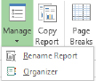
Report, Design ribbon bar Manage button
In the Organizer dialog box below you will notice that the Dashboard Reports file is located on the right side of the box and the Global.mpt values are on the left side of the box.
To copy the customized report “Resource Work Comparison Report” from the Dashboard Reports file to the Global.mpt file:
Click on the report name on the right
Click Copy in the center of the box
Click Close when finished
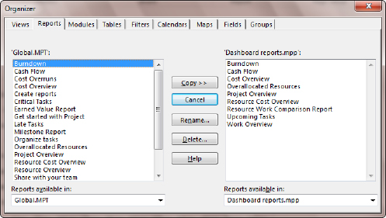
Objects are copied into the Global.mpt using the Organizer dialog box.
You can also use the Organizer to delete reports or rename reports.

